Project Phase-i report

AICTSL SERVICES INTEGRATION



Guided by |  | Submitted by
Prof. D.A. Mehta |  | Anita Bhadouria
 |  | Akanksha Sisodiya
 |  | Megha Jain
 |  | Palak Vaishnav
 |  | Pranjali Mogre

Computer Engineering Department
Shri G.S. Institute of Technology and Science
Indore (M.P.)
2015-2016

Shri G.S. Institute of Technology and Science
Indore (M.P.)


RECOMMENDATION

This is to certify that the project report entitled “ AICTSL Services Integration ” submitted by Anita Bhadouria , Akanksha Sisodiya , Megha Jain , Palak Vaishnav , Pranjali Mogre students of final year B.E. (Computer Engineering) in the year 2015 of this Institute, is a satisfactory account of their Project Phase-I work based on syllabus and the same is recommended for the Phase-I examination.

Prof. D.A. Mehta |  | Prof. D.A. Mehta
Guide |  | Head
Computer Engg. Department |  | Computer Engg. Department
S.G.S.I.T.S.  Indore |  | S.G.S.I.T.S.  Indore
 | Dean Academic
S.G.S.I.T.S.
Indore

Shri G.S. Institute of Technology and Science
Indore (M.P.)

CERTIFICATE

This is to certify that the project report entitled “ AICTSL Services Integration ” submitted by Anita Bhadouria , Akanksha Sisodiya , Megha Jain , Palak Vaishnav , Pranjali Mogre students of final year B.E. (Computer Engineering) in the year 2015 of this Institute, is a satisfactory account of their Project Phase-I work based on syllabus.

Internal Examiner |  | External Examiner

ABSTRACT

It is the era of technology in which the world is developing at very fast pace. Smart card automated fare collection systems are being used more and more by public transit agencies in big cities. In public transport system running by Atal Indore City Transport Services Ltd. (AICTSL) in Indore at present we use paper tickets which are printed by small machines with a key pad. Plastic cards are also used which are taken by commuter only once in a month at Rs.600 which are used in city bus by commuters. In this system we don’t know the details of commuters who are using public transport. The details of commuters are not taken in the existing system. Since AICTSL provides different services in city like I-Bus, City Bus, Tele-Rickshaw, I-Ride, in order to avail those multiple services commuter needs to have multiple cards for respective service. This could be a burdensome task for commuters to carry those multiple cards with him. This is one of the problems that commuters have to face on regular basis. Other problem is related to card theft. In present scenario no data is stored related to commuter because of which if commuter losses the card while travelling then that card could be found by someone else and could be misused. So there is need to save data of commuters so as to provide the secure use of card.
This review proposes use of smart card in the transit planning context. We have introduced the concept of integrating multiple cards for multiple services that would also be hybrid one. It means it would be cashless as well as cash-card both. The present system has separate cash and cashless cards. Integrating these cards in a single card would provide flexibility to the users to use card. Moreover, the cards used for services other than buses would only be cashless cards. This would actually help commuters to reduce their burden of carrying multiple cards and also provides blocking facility for lost cards that could be misused otherwise. For implementing such card we will be using RFID technology. RFID cards are read by RFID reader.
Alongside, the fare calculation and deduction will be automated. We will be using GPS system to track the location of vehicles. Using this location, fare can be calculated. GPRS module will be used for wireless connectivity with the server. A database server is also maintained at the backend keeping database of commuters, services, routes, fares etc.

INDEX
Chapter No. Content Page No.
1 | Introduction | 6
 | - Preamble | 6
 | - Need of the Project | 6
 | - Problem Statement | 7
 | - Objectives | 7
 | - Solution Approach | 7
 | - Organization of the Project Report | 8
2 | Background | 9
 | - Literature Review Write about research papers, contributions, disadvantages in them & their limitations. | 9
3 | Analysis | 10
 | - Detailed problem statement | 10
 | - Requirement Analysis  Functional Requirements  Non-Functional Requirements | 11
 | - Feasibility study | 12
 | - Diagrams | 13
4 | Design | 17
 | - Relational schema | 17
 | - Architecture Diagram | 25
 | - Flow Diagram | 26
 | - Activity Diagram | 31
5 | Conclusion | 36
 | 5.1. Work carried out in Phase-I. | 35
 | 5.2. Work to be carried out in next Phase | 36

CHAPTER 1: INTRODUCTION

  - PREAMBLE
The transportation system is the backbone of any city and a key part of its infrastructure. A large number of people use public transport in every big and small city. And talking about a big city like Indore, it is a major concern to have an effective and convenient transport system. In the context of rapid growth of the city, increasing mobility, high travel demand, increasing congestion, delays, accidents and other such problems, public mass transport system of the city stands out as the most critical element. Due to these reasons, Atal Indore City Transport Services Ltd. was started in 2005 with an aim to provide Effective Public Transport in the Indore City- a system which was reliable and contemporary, affordable yet profitable, fashionable yet sustainable. It is a public-private partnership agency set up to govern the whole transport of city. There are various players in this system: AICTSL, operators who operate and run city buses on different routes, advertisers who advertise their products on city buses and of course common people, who are the actual users of their services. The city bus offers daily passes to regular travelers. The city bus fare has been increased by Rs. 1 and now it's even more. The minimum charge for city bus is Rs. 8 and the monthly pass rate has been increased to Rs.600. This increase was attributed towards the recent crude oil price hike which made diesel and petrol costlier in India. The various services of AICTSL running currently are:-

- CITY BUSES
- I-BUSES
- I-RIDE
- TELE-RICKSHAW
- CHARTERED CABS & BUSES
1.2 NEED OF THE PROJECT
- FOR PASS DETAILS
Apart from the ticket system, which are to be bought from conductor to travel in city buses, there is monthly pass system for regular travelers in which they can travel anytime on any city bus. These passes are simple plastic cards with a photograph of traveler.
    - There is no record with issuing agency of the travelers.
    - If a pass gets lost, there is no way to retrieve it and freeze it so that others can’t use.
    - In case of any requirement, no authorized employee can see any information of passenger other than that on monthly pass.
- MULTIPLE CARDS FOR MULTIPLE SERVICES
Presently, there are either different cards for different services or there aren’t any cards for some services.
- A person having monthly city bus pass needs to pay separately for traveling in I-bus and vice-versa. This creates an ordeal for the daily users and puts an extra burden on their pockets.
- For each of the services, separate payment methods are there.

- TO REDUCE MANUAL WORK
Presently whole work is done manually, nothing is automated. This reduces involvement of the conductor.

- TO PROVIDE COMPLETE REVENUE TO AICTSL AUTHORITY
Presently the revenue is first received by the bus operators or rickshaw drivers and then it is provided to AICTSL authority and therefore operators and rickshaw drivers make profit by having more part from revenue.
1.3 PROBLEM STATEMENT
The services are independent of each other and user needs different modes to avail these services. The passes provided by the city bus authorities are merely plastic cards having no details about the passengers. Passenger is required to carry different passes for different services.
Our aim of the project "AICTSL Service Integration" is to solve the problems faced by the common man in using those services and also by AICTSL authorities especially related to their scheme of offering passes to regular customers.
1.4 OBJECTIVES
Our objective is to develop a system which is cost effective and provide convenience to the user as well as to the system. Our aim of the project "AICTSL Service Integration" is to solve the problems faced by the common man in using those services separately through the introduction of a multipurpose card, and also by AICTSL in maintaining a database of the customers and all the revenue and also reducing the manual work. We aim to implement a single card for all the services of AICTSL using RFID technology which works on RF waves.

1.5 SOLUTION APPROACH
In order to avoid the problem of handling multiple cards for the traveling purpose, concept of RFID cards is introduced. These cards are multipurpose cards, which can be used during different services, serving as an All-in-one card.
But then there are two types of cards:
Cash Card: It is a card in which we can make a fix payment and avail unlimited service as in present day monthly passes.
Cashless Card: It is the card in which we get a balance of some amount by recharging it and each time we use a service, balance is deducted as per the guidelines. So it is obvious that we cannot use a cash card for services like i-ride and Tele-rickshaw, but using cash cards for city buses and i-buses is a good option.
So the card should be a hybrid card- serving as a cash card as well as a cashless card at times.
Moreover the cards used nowadays if lost cannot be destroyed i.e. anyone else can use it besides that there is no information about the user who issues the card so that if his card is lost he can at least be informed.
RFID cards provides solution to this problem also. The information about all the users will be stored in the database servers. The moment when the RFID card is swiped, a connection is made with the server and all information about that user is displayed ,we can say that the RFID card contains information about its user .
Moreover the problem of card lost is solved. This is done by freezing the card as per the request of the user, so no misuse of card is possible.
1.6 ORGANISATION OF THE REPORT
The rest of the report is organized as follows:
Chapter 1, Introduction, gives the problem statement with an overview of the problem domain and proposed solution.
Chapter 2, Background, describes in detail the literature survey done to understand the concept of revenue collection and problem associated with the current fair collection through plastic card.
Chapter 3, Analysis, describes the problem statement of our work. It deals with the feasibility study, functional and non-functional requirements, Use case analysis and ER Diagram.
Chapter 4, Design, focuses on the design details comprising of the basic architecture of the application, the basic architecture of the system, data base tables, flow diagrams and activity diagram.
Chapter 5, Conclusion, concludes the report. It briefly discusses the entire research work done for the project and also the work that has to be done for the project.

CHAPTER 2: BACKGROUND

2.1 LITERATURE REVIEW
In the present scenario there is a single card on which a fixed recharge is done which is valid for 1 month through which one can travel in city bus whenever one wants.
But there are some flaws in this system –

1. The card is a simple plastic card with no details in it.
2. There is no mechanism if the card gets lost.
3. One can’t use this card for I-bus and has to pay money while travelling in i-bus although he has a card.
4. Services such as I-ride and Tele-rickshaw cannot be used with the help of this card. He will have to carry cash in order to use these services.
5. No user data is available with the AICTSL.

There is no mechanism if the card gets lost and hence it can be misused which will be a loss for AICTSL since its services are being used free of cost. AICTSL has presently made a draft of Project Report (DPR) in which it is mentioned about the proposal and the suggestions for the card. They mentioned the need of RFID card and the concept of cash card and cashless card .A cash card is a monthly card in which a user pays a fixed amount of money and can use the card for city bus and I bus for a period of one month. A cashless card works like a recharge in a phone, user recharges his card according to his need and can use this money for services like I-ride, Tele-rickshaw and even in the case of I-bus and city bus if its validity expires.

CHAPTER 3: ANALYSIS

3.1 DETAILED PROBLEM STATEMENT
The transportation system is the backbone of any city and a key part of its infrastructure. A large number of people use public transport in every big and small city. And talking about a big city like Indore, it is a major concern to have an effective and convenient transport system. In the context of rapid growth of the city, increasing mobility, high travel demand, increasing congestion, delays, accidents and other such problems, public mass transport system of the city stands out as the most critical element. Due to these reasons, Atal Indore City Transport Services Ltd. (AICTSL) is established in Dec. 2005 to provide an efficient transport system in Indore city. The various services provided by AICTSL for transportation are:
- City buses
- Routes: City buses are running on 18 high travel demand routes in Indore with thousands of passengers travelling every day.
- Operating agency: These buses are operated by various operators. Each operator run buses on 1 or more routes.
- Sources of revenue: The main source of revenue for the company is the monthly premium amount received from the bus operators, advertising revenue and the share of revenue generated through passes. The sources of revenue for the bus operators are the daily fare box collection, share of revenue generated through advertising on buses and monthly passes.
- Fare Collection System: The city buses uses ticketing and monthly pass system for the travelers. Monthly passes are the cash cards, available at rs 600/- for all using which one can travel across all the routes in city buses, valid for one month. The tickets are drawn by the city bus conductors in which fare is calculated as per the distance (in km) between source & destination. Smart cards are also available, which are cashless cards and balance is deducted from them, each time the passenger travels I n the city bus. Smart cards are provided by the operators, and not AICTSL.
- Pass & ticket technology: The tickets are the simple paper tickets drawn by a machine. The conductor feeds the source and destination for the ticket and the ticket gets printed, specifying the fare as per the predefined charges fed in the machine.
The monthly passes are the plastic cards issued by various pass centers located across city. The traveler’s photo is scanned and other details like name, age, address and validity of card is specified on the pass. These passes are not able to provide any other info.
2. I-buses
- Routes: The I-buses run on the BRTS corridor. These are low-floor, semi-automated, air-conditioned buses which have automated doors.
- Operating Agency: I-buses are operated by AICTSL itself. AICTSL looks for the maintenance and operation of these buses.
- Sources of Revenue:Daily fare box collection is the source of revenue for the company.
- Fare Collection System and technology: The fare is collected by issuing tickets to the passengers. No pass system is there for the I-buses. The tickets are drawn same as that of city-buses, the only difference being that, here tickets are issued at the bus stops only before boarding on the buses.
3. I-ride and Tele-rickshaw
- Routes: There is no route for the I-ride i.e. Bike service and Tele-rickshaw. The people can take the bikes on rent by first registering at AICTSL office center. In Tele- Rickshaw service, people can hire rickshaw for travelling in any part of city. The rickshaw can be booked by a phone-call.
- Operating Agency: AICTSL
- Sources of Revenue: Whatever money is earned from the bike- rent and rickshaw fare is the main source of revenue.
- Fare Collection System & technology: Manual fare collection is done at the I-ride counter and by the rickshaw driver for the I-ride and Tele rickshaw respectively.
As we can see, there are many problems with the current fare collection system.
- These services are scattered all around. These services are not integrated rather separate individual units. A person using monthly pass in the city bus can’t use the same pass for travelling in I-bus. This is a big problem for frequent or daily users who use to go through both the routes. This results in a greater expense and inconvenience. Even if we implement card system for I-buses, no one would be willing to pay for two separate I-bus & city bus pass.
- Most things are done manually. There is no automation or latest technology used in the fare collection system. The city bus passes that AICTSL issues are simple plastic cards without having any identity and solid authentication scheme. If anyone loses his/her card, the person stealing the card can easily use it. Moreover, we can’t get any further information about the person holding the card, other than what is printed over it.
- Right now, the company doesn’t keep record the daily users who use passes. The passes are of “use & throw” type and no details are kept for further acknowledgement. There is no database with the company.
- The manual fare collection may result in stealing and mishandling by the intermediaries like conductors and rickshaw driver.
These problems call for the need to have better and modern fare collection system which is more user friendly, company friendly and robust.
3.2 REQUIREMENT ANALYSIS
3.2.1 FUNCTIONAL REQUIREMENTS:
- Multipurpose Card so that the same card can be used in all the services of AICTSL and the user is not required to carry different cards. This card will be a Hybrid card (Cash card + Cashless card) and its use will depend upon the service. This should be a Hybrid card, i.e. commuter should be able to pay via cash mode or cashless mode.
- Automated System: Fare calculation, validity check and fare deduction should be done automatically. The use of this system will reduce their dependency on conductors as they will just have to tap their cards against the readers.
- An SMS will be sent to the users if their card reaches a minimum balance so that they can recharge their card much before.
- Through the GPRS Module, locations of buses can be known.
- A beep is given whenever a card has insufficient balance so that the conductor can easily come to know and can stop the user from illegally boarding the bus.
- All the details of the card holder is stored in the database and the AICTSL authorities can easily use that data so users can access and manipulate the data.
3.2.2. NON FUNCTIONAL REQUIREMENTS:
- Security: Commuter's money will be safe as they will directly pay to AICTSL Authorities and will just tap their cards so there is no middleware involved and their money remains safe.
- Blocking of cards: If a user's card gets lost then he/she can directly go the AICTSL Authorities and block the card and so no other person can use that card.
3.3 FEASIBILITY STUDY OF PROPOSED SYSTEM
The purpose of this part is to determine the feasibility of implementing various technologies in transit systems within AICTSL to assist in collection and accounting of commuters’ fares.
3.3.1 OPERATIONAL FEASIBILITY:-Considering from the arrival of bus at bus stoppage, the reader will read the tag when commuters enter inside the bus. Also the reader being connected to the main server, the data will automatically transfer to the server database. All the passengers will carry a prepaid system RFID based card that will have a unique ID number. The card is rechargeable from certain electronic booths placed at certain locations of the city. The reader will detect the tag and require certain information from the passenger. According to the route distance between departure & destination, it will calculate the ticket fare and deduct the credit from the RFID tag based ticket electronically.
3.3.2 TECHNICAL FEASIBILITY:- We will be using RFID technology where tags will be tapped against readers interfaced with microcontrollers and connected to the main server through GSM/GPRS Modules.
RFID TAGS:
The RFID tag element consists of an antenna integrated with a microchip. The RFID reader and antenna transmit an electromagnetic RF signal. This signal is received by RFID tag via tag's antenna. The energy in the received signal provides power to the tag that allow the microchip to operate. This is what we refer to as “passive” tag. We will be using a read-only tag where some data is permanently stored. They have practical read distance ranging from about 10 cm up to a few meters. Since they require no power, they have unlimited lifespan.
RFID READER:
For passive tags reader energize the tags with energy, receive the results. Readers are generally controlled via a software application programming interface(API) that is provided by the reader manufacturer. Generally, API also allows for configuring the reader's read cycle, power or other setting. The API software libraries for a given reader may be priced separately for the reader.
RFID ANTENNA:
Intermec RFID antennas provide the vital link between reader and tag, serving as the conduit that moves data back and forth.
MICROCONTROLLER:
Required for interfacing of readers, Odometer, GSM/GPRS module so as to connect with the main server that resides at the AICTSL office.
APPLICATION SERVER:
Java Programs so as to perform functions as retrieval of information from the database, fare calculation, checking validity, authenticating user information, etc.
3.3.3 ECONOMIC FEASIBILITY:
This project is economically feasible in the long run as the authorities are facing so many problems with the current scenario and so shall be implementing the RFID enabled smart cards. Once the project is implemented, AICTSL Authorities will have to make a large investment in the initial phase, they may not get profits from it in the short run but it will be beneficial and cost effective in the long run.
Initially, cards will be made for the customers; readers will installed in every bus, Tele-rickshaw and AICTSL Office which will require huge investment. But in the long run, the whole revenue goes directly to the AICTSL Authorities and no middleware is involved so the project is economically feasible for the Authorities.
3.4 DIAGRAMS
3.4.1 USECASE DIAGRAM
BASIC FLOW:
- There are 2 actors in our system - AICTSL Admin and the commuters.
- The card is issued by the AICTSL Authorities for which it is compulsory to add the user information in the database.
- Commuters will tap the card against the reader and enjoy multiple services. Services can be 3 types - Buses, I-ride, Tele- rickshaw. He cannot access any of the services until the validity of his card is checked from the database.
- Balance can be deducted from the card (in case of Cashless Card) or the balance remains intact (in case of Cash Card) when taped against a reader.
- Commuters also report card lost to the AICTSL Authorities for which the authorities will block the card immediately and the changes will be made in the database.

ALTERNATE FLOW:

When the commuter taps a card against a reader, if the balance is less than the minimum balance or if the validity expires, he is required to go to recharge center to recharge his card.
Figure 3.1: Use Case describing the System
3.4.2 ENTITY-RELATIONSHIP DIAGRAM
- Commuter travels through any one of the services. He carries with him a hybrid card that has a unique tag id. The information of the traveler like his name, DOB, gender, contact number, email, etc. The validity of his card and his balance is also stored in the database.
- Commuter uses a particular service (I-bus, City bus, I-ride, Tele-rickshaw) at a particular time and date which has a unique service id where service id and its type is stored in the database.
- Many people can use many services hence the relation M: N.
- It is compulsory for each service to be either be a bus , rickshaw or i-ride hence it shows total participation (using double lines) .
- A service cannot be both a bus and rickshaw hence the disjoint relationship using (d) notation.
- A Tele-rickshaw has an owner, his contact number and the vehicle registration number.
- A bus has its route number and last stop.
- I-ride service’s bikes have a bike number.
- Commuter can go the AICTSL Office to recharge his card at a particular time and date and can recharge according to the service.
- It is necessary for every service to generate a fare hence it shows total participation (using double lines). A service generates a fare hence 1:1 relationship.
- Fare is according to last stop and area.
Figure 3.2: Entity-Relationship diagram

CHAPTER 4: DESIGN

4.1 RELATIONAL SCHEMA
USER
Tag id | Name | Gender | DOB | Email | Cashless_validity | Cash_validity | Bal | block | Contact_no

SERVICES
Service_id | Type

FARE
Area | Last_stop | Fare

BUS_SERVICE
Service_id | Last_stop | Route_no

DEDUCTIONS
Tag_id | Amount | Date | Time | Service_id

TELE_RICKSHAW
Rid | Name | Conatct_no | Vehicle_no

BIKE
Bike_id | Bike_no

RECHARGE_HISTORY
Tag_id | Date | Time | Recharge_type | Amount

Figure 4.1: Relational Schema

4.2 ARCHITECTURE DIAGRAM
Every time the commuter uses the AICTSL Services he/she has to tap the card with in-built Reader that will be the front end of our architecture. The passive reader gets power from the reader and reader reads the tag ID. After reading the tag ID, here comes the use of interfacing modules like Microcontroller, GSM/GPRS. Reader interfaces with Microcontroller and passes this ID to microcontroller. Microcontroller will be programmed in such a way so as to send data i.e. tag id, service id & location to the application server with the help of GSM/GPRS module. The entire Business Logic (processing) is made to get executed on Application Server. Based on the user data received from Microcontroller a program would execute on application server that will be connected with Database server by java database connectivity (JDBC). This program would check for validity & update the balance in the database.
THE HARDWARE COMPONENTS REQUIRED ARE
- Em-18 RFID module - It consists of reader and tag of frequency 125Khz
- Arduino ATmega2560
- 16x2 Alphanumeric LCD
- Digital Odometer
- SIM 900 GSM/GPRS Module
- Electronic Buzzer
- Breadboard
THE SOFTWARE COMPONENTS REQUIRED ARE

- JDBC Driver
- Eclipse IDE
- Arduino Software

Arduino atmega2560
Arduino is an open-source computer hardware and software company, project and user community that designs and manufactures microcontroller-based kits for building digital devices and interactive objects that can sense and control objects in the physical world.
The Mega 2560 is a microcontroller board based on the ATmega2560. It has 54 digital input/output pins (of which 15 can be used as PWM outputs), 16 analog inputs, 4 UARTs (hardware serial ports), a 16 MHz crystal oscillator, a USB connection, a power jack, an ICSP header, and a reset button. It contains everything needed to support the microcontroller; simply connect it to a computer with a USB cable or power it with a AC-to-DC adapter or battery to get started.
We have selected arduino 2560 because it is simple and has clear programming environment. Also it is
inexpensive - Arduino boards are relatively inexpensive compared to other microcontroller platforms. The least expensive version of the Arduino module can be assembled by hand, and even the pre-assembled Arduino modules cost less than $50
Cross-platform - The Arduino Software (IDE) runs on Windows, Macintosh OSX, and Linux operating systems. Most microcontroller systems are limited to Windows.
Features of arduino 2560
256KBytes of In-System Self-Programmable Flash
– 4Kbytes EEPROM
– 8Kbytes Internal SRAM
-Four Programmable Serial USART
Port A (PA7..PA0)
Port A is an 8-bit bi-directional I/O port with internal pull-up resistors (selected for each bit). The Port A output buffers have symmetrical drive characteristics with both high sink and source capability. As inputs, Port A pins that are externally pulled low will source current if the pull-up resistors are activated. The Port A pins are tri-stated when areset condition becomes active, even if the clock is not running.
Port F (PF7..PF0)
Port F serves as analog inputs to the A/D Converter.Port F also serves as an 8-bit bi-directional I/O port, if the A/D Converter is not used.
ort G (PG5..PG0)
Port G is a 6-bit I/O port with internal pull-up resistors (selected for each bit). The Port G output buffers have sym-metrical drive characteristics with bothhigh sink and source capability. As inputs, Port G pins that are externallypulled low will source current ifthe pull-up resistors are activated.
Port H (PH7..PH0)
Port H is a 8-bit bi-directional I/O port with internal pull-up resistors (selected for each bit). The Port H output buf-fers have symmetrical drive characteristics with both high sink and source capability. As inputs, Port H pins that areexternally pulled low will sourcecurrent if the pull-up resistors are activated.
Interfacing of LCD wih arduino 2560.
The JHD162A has 16 pins and can be operated in 4-bit mode or 8-bit
mode. Here we are using the LCD module in 4-bit mode

Pin1(Vss):Ground pin of the LCD module.
Pin2(Vcc):+5V supply is given to this pin
Pin3(VEE):Contrast adjustment pin. This is done by connecting the ends
of a 10K potentimeter to +5V and ground and then connecting the slider
pin to the VEE pin. The voltage at the VEE pin defines the contrast. The
normal setting is between 0.4 and 0.9V.
Pin4(RS):Register select pin.The JHD162A has two registers namely
command register and data register. Logic HIGH at RS pin selects data
register and logic LOW at RS pin will select command register. If we make
the RS pin HIGH and put a data on the data lines (DB0 to DB7) it will be
recognized as a data. If we make the RS pin LOW and put a data on the
data lines, then it will be taken as a command.
Pin5(R/W): Read/Write modes. This pin is used for selecting between
read and write modes. Logic HIGH at this pin activates read mode and
logic LOW at this pin activates write mode.
Pin6(E): This pin is meant for enabling the LCD module. A HIGH to LOW
signal at this pin will enable the module.
Pin7(DB0) to Pin14(DB7): These are data pins. The commands and data
are put on these pins.
Pin15(LED+): Anode of the back light LED. When operated on 5V, a 560
ohm resistor should be connected in series to this pin. In arduino based
projects the back light LED can be powered from the 3.3V source on the
arduino board.
Pin16(LED-):

RS pin of the LCD module is connected to digital pin 12 of the arduino.
R/W pin of the LCD is grounded. Enable pin of the LCD module is
connected to digital pin 11 of the arduino. In this project, the LCD module
and arduino are interfaced in the 4-bit mode. That means only four of
the digital input lines( DB4 to DB7 of the LCD are used). This method is
very simple, requires less connections and you can almost utilize the full
potential of the LCD module. Digital lines DB4, DB5, DB6 and DB7 are
interfaced to digital pins 5, 4, 3 and 2 of the Arduino. The 10K
potentiometer is used for adjusting the contrast of the display. 560 ohm
resistor R1 limits the current through the back light LED. The arduino can
be powered through the external power jack provided on the board. +5V
required in some other parts of the circuit can be tapped from the 5V
source on the arduino board. The arduino can be also powered from the
PC through the USB port.

Program…
#include<LiquidCrystal.h>
LiquidCrystal lcd(12, 11, 5, 4, 3, 2); // sets the inter
facing pins
void setup()
{
lcd.begin(16, 2); // initializes the 16x2 LCD
}
void loop()
{
lcd.setCursor(0,0); //sets the cursor at row
0 column 0
lcd.print("16x2 LCD MODULE"); // prints 16x2 LCD MODULE
lcd.setCursor(2,1); //sets the cursor at row
1 column 2
lcd.print("HELLO WORLD"); // prints HELLO WORLD
}

Interfacing of rfid reader with arduino atmega2560
RFID is Radio Frequency Identification. An RFID reader is used to
read RFID tags (which contain certain unique data stored in a chip). An
RFID reader and an RFID tag, both have a coil surrounding them. When
an RFID tag is shown near an RFID Reader, it collects the unique tag data
(a combination of digits and characters) from the RFID tag.

Make sure you connect Ground Pin of RFID
reader to Ground Pin of Arduino. I am using the SoftwareSerial Library of
Arduino which enables digital pins to be used in serial communication. I
have used pin 9 as the Rx of Arduino.

Program
#include <SoftwareSerial.h>
SoftwareSerial mySerial(9, 10);
void setup()
{
mySerial.begin(9600); // Setting the baud rate of Softw
are Serial Library
Serial.begin(9600); //Setting the baud rate of Serial
Monitor
}void loop()
{
if(mySerial.available()>0)
{
Serial.write(mySerial.read());
}
}

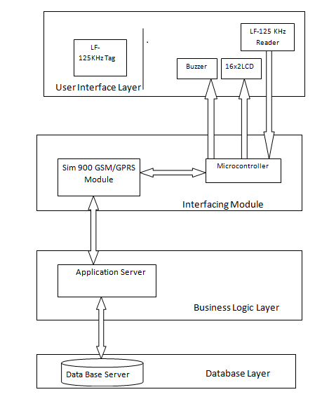
Figure 4.2: Architecture Diagram for the System
4.3 FLOW DIAGRAMS
    - FLOW DIAGRAM FOR I- BUS AND CITY BUS
The flow diagram for I-bus and City bus is shown in figure 4.3.
- The traveler enters the bus and taps the card against the reader installed at the gate of the bus (I-bus and city bus). The reader reads the card ID. It is interfaced with the microcontroller which in turn is interfaced with the GSM/GPRS module.
- The microcontroller sends tag ID and service Id to the Application server wirelessly through the GSM/GPRS module.
- The Application server fetches the details from the database for the desired tag ID and service ID. It checks for the validity of the cash card. Two situation arise:
- If validity > =current date, the Application server sends the status to microcontroller through GSM/GPRS module.
- If Validity < current date or validity = NULL, it checks for the validity of the cashless card. Again two situation arise-:
- If balance > minimum balance, the Application server deducts the balance from the card and sends the appropriate status to microcontroller through GSM/GPRS module.
- If balance < minimum balance, the Application server sends the appropriate status to microcontroller through GSM/GPRS module. The microcontroller than generates the alarm.
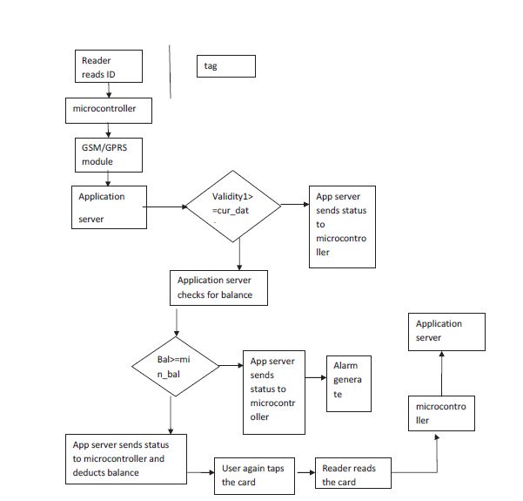
Figure 4.3: Flow Diagram for I-Bus and city bus
HOW IS THE BALANCE DEDUCTED FROM THE CASHLESS CARD IN CITY BUS AND I-BUS
A commuter can use his cashless card while travelling in the bus and the fare will be deducted from his card accordingly. There are various ways through which he can use his cashless card to travel in bus, they are –
- The user enters the bus, taps his card and enters the destination. For that the reader will have a unique button corresponding to each destination and the user will press the desired button.
But there are two problems with this
- The user can enter the wrong destination
- Due to excessive crowd in the bus the conductor may not be able to keep track of all card holders, and some card holders may travel without tapping their card.
- The conductor enters the destination of the user.
This approach has two problems-
- The user can tell wrong destination as he knows that conductor won’t remember
- Manual work will be increased
- It will be a time consuming process in case of excess crowd
3.
A
C

B

Figure 4.4: Bus stops
The 3rd method can be explained with the help of figure 4.4.
Here A is the boarding stop, C is the final stop of the bus and B is the destination stop of the commuter. When the commuter enters the bus, he will tap his card and the fare will be deducted which is the fare from A to C. The commuter will again tap his card when he leaves the bus and then the fare from B to C will be added to his card. The only limitation with this method is that he will have to have a minimum balance of Rs.25method number 3 is found to be more efficient among all and we will be working on this method.
    - FLOW DIAGRAM OF TELERICKSHAW
The traveler taps the card against the reader installed in the Tele-rickshaw. The reader reads the card ID. It sends the Id to the microcontroller interfaced with it. The microcontroller is interfaced with the odometer. At the end of the trip the user again taps the card and the distance is calculated by microcontroller with the help of odometer. The fare is deducted accordingly and is displayed on the LCD

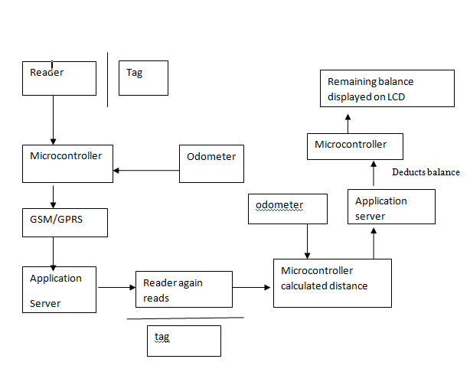
Figure 4.5: Flow Diagram for Tele Rickshaw
    - FLOW DIAGRAM OF I-RIDE
- The traveler taps his card in the AICTSL office. The reader reads the tag ID and sends send it to the microcontroller interfaced with it.
- The microcontroller sends this tag ID and service ID to the Application server wirelessly through the GSM/GPRS module and records the current time.
- When the traveler returns he again taps the card against the reader which again sends the service ID and tag ID to the microcontroller. The microcontroller saves the current time and sends it to the application server along with service ID
- and tag ID.
- The Application server fetches the details from the database for the desired tag ID and service ID, calculates the time difference and fare and deducts the fare accordingly.
- It then sends the remaining balance to the microcontroller which then displays on the LCD.

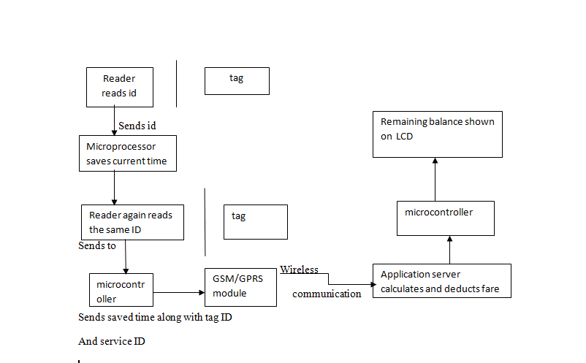
Figure 4.6: Flow Diagram for I-Ride
4.4 ACTIVITY DIAGRAM
4.4.1 ACTIVITY DIAGRAM FOR I-RIDE
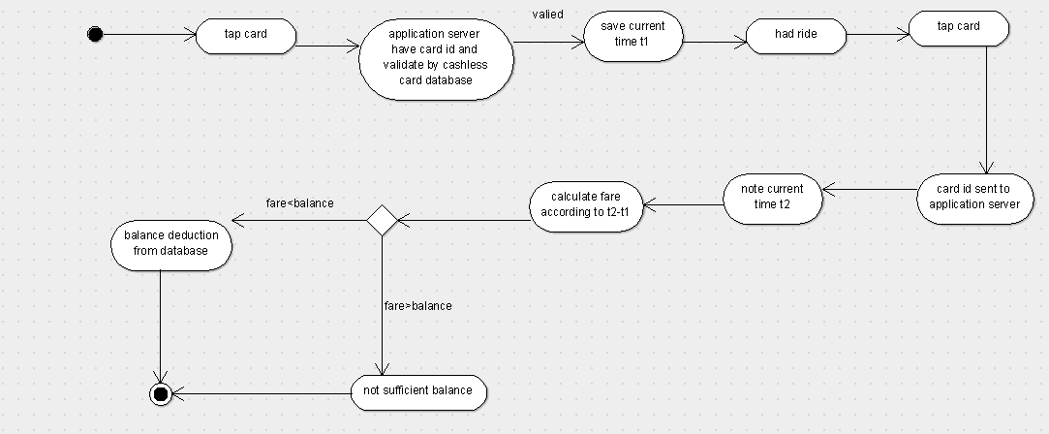
Figure 4.7: Activity Diagram for I-Ride
4.4.2 ACTIVITY DIAGRAM FOR BUS
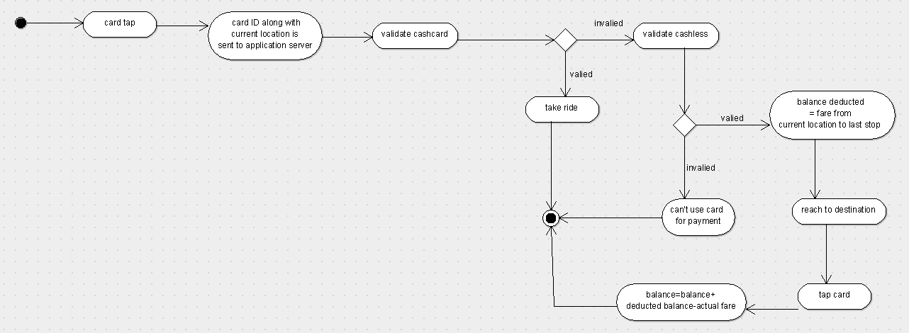
Figure 4.8: Activity Diagram for I-Bus and City Bus
4.4.2.1 VALIDATE CASH CARD
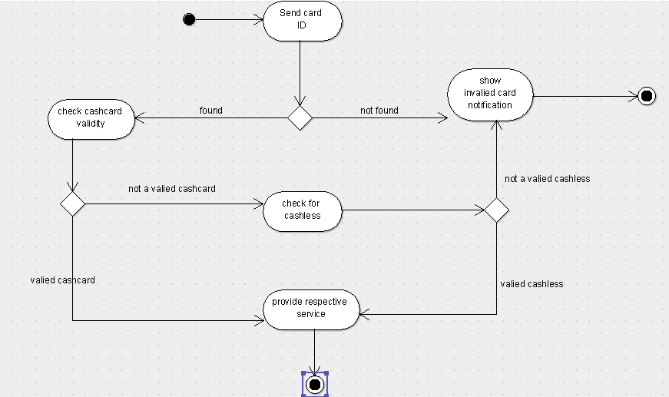
Figure 4.9: Activity Diagram for Cash Card Validation
4.4.3 ACTIVITY DIAGRAM FOR TELERICKSHAW

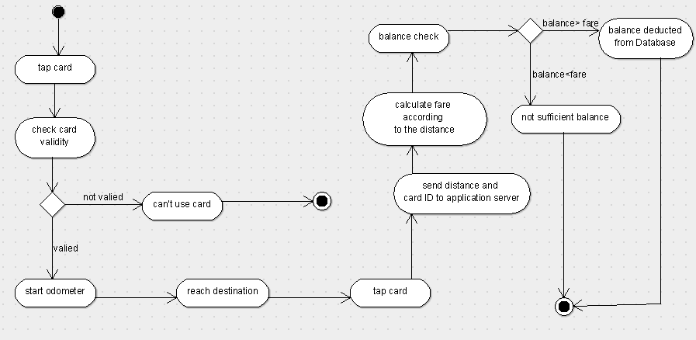
Figure 4.10: Activity Diagram for Tele Rickshaw

CHAPTER 5: CONCLUSION

5.1 WORK CARRIED OUT IN PHASE-1
- We analyzed the problems with the AICTSL Services and the major problem among them was the inconvenience to the users that he can't use the card of city bus in I-bus also. We came up with a solution where a single card can be used in all kinds of services.
- We will be designing a multipurpose card based on RFID Technology which will be a Hybrid Card (a combination of Cash Card and Cashless Card). The RFID Card is taped against a Reader and the processing is done.
- We also analyzed the flow of certain processes which includes the working of RFID card, what happens when it is taped against a reader, why do we need Microcontroller, how the location of bus and Telerickshaw is tracked and finally how the balance is deducted.
- We also developed the Database needed for the project and what information about the user and the services should be present in the database.
- We also designed the Architecture for our project which would be referred frequently for developing the prototype.
- After analyzing the whole scenario and the technologies, we can conclude that this project is feasible and is sellable and the whole control lies in the hands of AICTSL Authorities. Apart from this, by developing this project, the whole revenue goes to the AICTSL which is then distributed among different operators accordingly.
5.2 WORK TO BE CARRIED OUT IN NEXT PHASE
We will be buying a RFID module with frequency 125 kHz. The tag will be passive that is, it will be tapped against the reader and will take power from it.Interfacing between microcontroller and the reader is done with the help of UART and the interfacing between microcontroller and application server is done with the help of RS232 .The programming of microcontroller will be done in embedded C.Microcontroller will be programmed in such a way that it sends the tag ID received from reader, time, distance and service ID to the Application server.
Application server is server where java applications will run. It will receive tag ID, service ID or time and it fetches data from the database server. It then performs the query execution like calculating fare, checking time validity, checking blocked cards, adding new user balance deduction etc.
We will be having GSM/GPRS module for wireless connectivity between microcontroller and the application server. Also it will be used for tracking the location of bus when a user uses his cashless card to travel in bus and sends this location to the application server which deducts the fare according to the stop of the bus.We will be buying a RFID module with frequency 125 kHz. The tag will be passive that is, it will be tapped against the reader and will take power from it.Interfacing between microcontroller and the reader is done with the help of UART and the interfacing between microcontroller and application server is done with the help of RS232 .The programming of microcontroller will be done in embedded C. Microcontroller will be programmed in such a way that it sends the tag ID received from reader, time, distance and service ID to the Application server.
Application server is server where java applications will run. It will receive tag ID, service ID or time and it fetches data from the database server. It then performs the query execution like calculating fare, checking time validity, checking blocked cards, adding new user balance deduction etc.
We will be having GSM/GPRS module for wireless connectivity between microcontroller and the application server. Also it will be used for tracking the location of bus when a user uses his cashless card to travel in bus and sends this location to the application server which deducts the fare according to the stop of the bus.

References

[1]. D. C. Karaiskos , P. Kourouthanassis and G.M. Giaglis , "User acceptance of pervasive information systems : evaluating an RFID ticketing system ", in Proceedings of ECIS , Athens, Greece , 2007
[2]. J.L. Wang , "Privacy and ethical issues in location-based tracking systems", in Proceedings of IEEE International Symposium on Technology and Society , Illinois , USA,2009
[3]. A-R Sadeghi , I. Visconti , and C. Wachsmann . User privacy in transport systems based on RFID e-tickets.
[4]. Mr. Rahul Shrouti , Technical Manager , AICTSL.
[5]. Wal-Mart spells out RFID vision , RFID Journal 2003 . Retrieved 8-09-2010 , from http://www.rfidjournal.com/article/purchase/463

